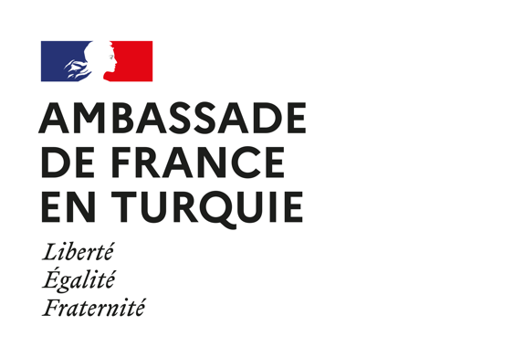
Regulations for the 2024 Sport and Inclusion call for proposals

ARTICLE 1: OBJECT

1.1. The French Embassy in Türkiye supports civil society projects every year in accordance with its commitments for human rights and the sustainable development goals. In particular, this call is organised in order to support projects carried out by NGOs that contribute to highlight the values of sport such as diversity and inclusiveness.

1.2. For this unique call for project proposals in the field of sport and inclusion, we will pay attention to projects aiming at reduce discriminations through sport. We will pay a special attention to projects featuring:

- A nod to the French-speaking world;
- Inclusivity: strengthening and encouraging the participation of minorities (age, gender, origin, disability) in sport;
- Concrete actions with an advocacy component;
- Strengthening Franco-Turkish friendship and cooperation;
- Strengthening the technical capacities of civil society organisations;
- Innovative solutions to some of the crucial issues facing the world of sport today;
- Involvement of stakeholders in the regions affected by the earthquakes of 6 February 2023.

1.3. The selected projects will raise public awareness on these questions; strengthen the technical capacities of civil society organizations; define strategies and / or disseminate good practices.

ARTICLE 2 – CONDITIONS

2.1. The application must be submitted in French or in English and automatically involves the acceptance of these regulations.

2.2. The selected projects will be granted between 5,000 and 10,000 euros each, for a total amount of 20,000 euros. The Embassy may decide to give a lower amount than what the applicant request.

ARTICLE 3 - ELIGIBILITY CRITERIA

3.1. Projects must start at the latest on 15 June 2024 and must end before 30 November 2024.

3.2. The analysis framework is based on 6 criteria: relevance, coherence, effectiveness, efficiency, impact, sustainability (over time).

3.3. Projects that will have a leverage effect to larger projects will be valued. The consideration of cross-cutting factors (Human Rights, Education, etc.) will also be valued. As far as possible, the project must involve other local partners. The French Embassy will take into consideration the carbon footprint of the projects it finances. The projects will have to plan appropriate communication and transparency actions.

3.4. Only NGOs with a legal status (Dernek, Vakıf, etc.) are eligible for these funds.

3.5. The requested grant must not exceed 80% of the whole project budget and the operational costs (administrative costs not directly related to the project, office equipment, and rent) must not outreach 20% of the whole project budget.

ARTICLE 4 – JURY

The jury will be chosen by the French Embassy in Türkiye. It may include members of Turkish civil society, members of French local institutions and members of International Organizations.

ARTICLE 5 - APPLICATION PROCESS

5.1. The files of the candidate associations must be sent by email to the Cooperation with Civil Society Officer, at the address siviltoplum@ifturquie.org before 1st May 2024.

5.2. The documents to be provided are:
- Project proposal with budget (in English; template from the French embassy);
- Cover letter (in English or French; free format);
- Statutes of the applicant (Tüzük; a translation in French or English will also be requested).

ARTICLE 6 - PAYMENT OF ENDOWMENTS

6.1. A decision of the jury will be given by the end of May 2024.

6.2. A grant agreement must be signed by the two parties (French Embassy in Türkiye and winning organization) in order to release the grant.

6.3. The grant will be paid in Euros or Turkish liras at the rate in force on the date of payment.

ARTICLE 7 – MODIFICATIONS

7.1. Any significant change affecting the objectives, partners, calendar or budget of a selected project must be reported and validated by the French Embassy in Turkiye.

7.2. Failure to comply with this clause or partial or complete non-completion of the project may result in the reallocation of the funding granted or the full or partial reimbursement of the sums.

ARTICLE 8 - OBLIGATION OF THE WINNERS

8.1. At the end of its project, the winning associations commit to return to the Embassy of France in Türkiye a final report for which they will receive the template. These documents will be signed and be submitted by e-mail within two months after the end of the project.

8.2. The winning association authorizes the publication and use by the Embassy of France and the French Institute of Türkiye of its name, information relating to the funded project, intermediate and final reviews, photos, videos and waives collection any right or indemnity in this respect.
8.3. The winning association must use the logo of the French Embassy in any communication related to the selected project.

8.4. The winning NGOs could take benefit of the French Embassy and the “Institut français de Turquie” premises (in Ankara, Istanbul and Izmir) for the organization of events in the framework of the project (subject to premises availability).

ARTICLE 9 - INSURANCE OF WINNERS

9.1. In the event of an accident, the winning association is solely responsible for their project and are covered by the necessary insurance. It therefore disclaims any and all liability from the French Embassy in Türkiye and the funding bodies from any responsibility in the event of an accident and will not have any recourse against them.

9.2. The selected projects have to comply with the law and the funding body is not responsible for any illegal activity during the implementation of the project supported.

