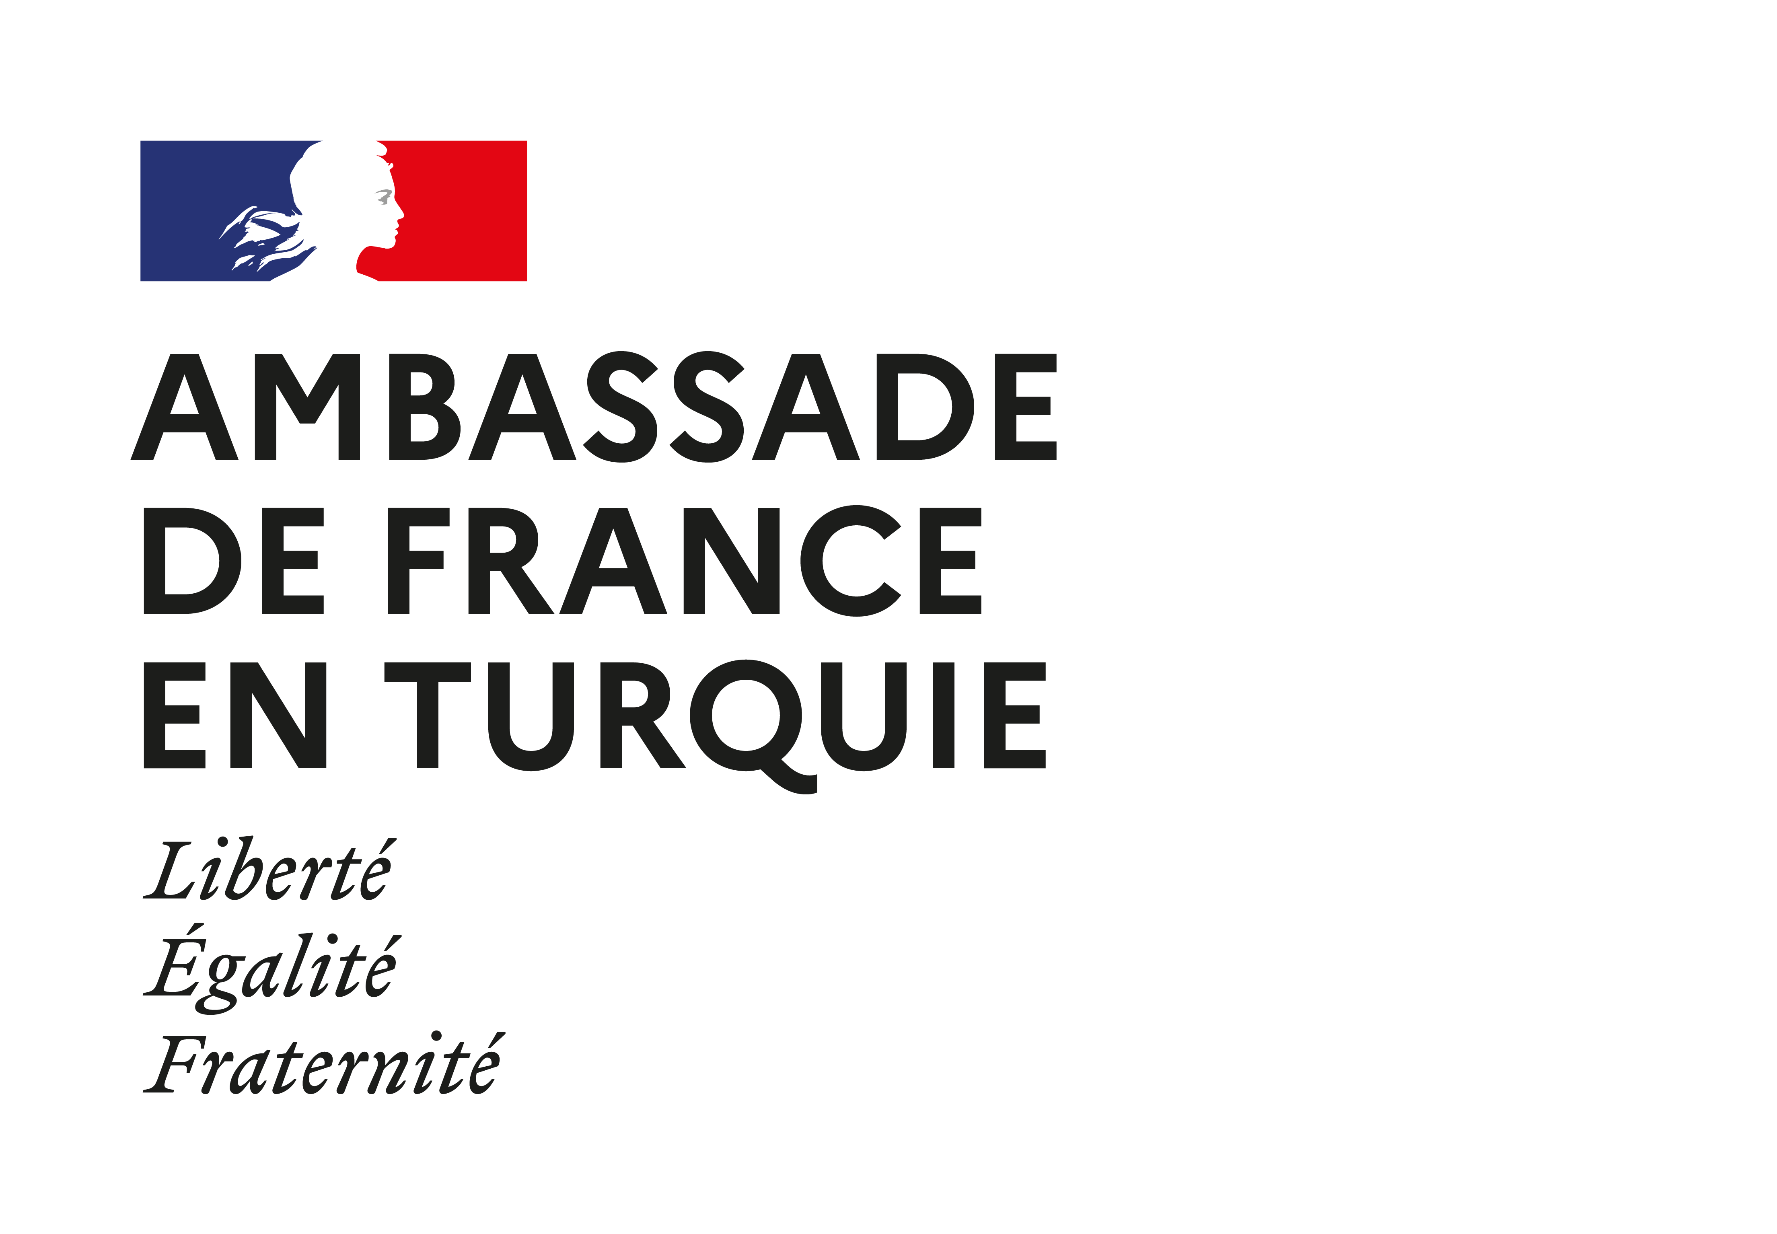

AMBASSADE DE FRANCE EN TURQUIE
Service de Coopération et d’Action Culturelle

French Embassy Research Fellowships

The Embassy of France in Turkey is launching three fellowships for the year 2023:

- Fellowship for PhD students
- Fellowship for Young Visiting Researchers (Submission up to 3 years after acceptance in a PhD program)
- Fellowship for Visiting Researchers

France and Turkey have an historical cooperation in the field of higher education and research. The French Embassy has supported the implementation of several structural bilateral programs such as the PHC Bosphorus, the French Institute for Anatolian Studies (IFEA), and the French Government Fellowships. Numerous cooperation agreements exist between universities from both countries, and the French-Turkish Galatasaray University is amongst the most prestigious Higher Education institutions in Turkey.

It is a priority for the Embassy of France to foster new collaborations opportunities between Turkish and French researchers in order to enhance and maintain a fruitful relationship between our two countries.

This fellowship call constitutes an opportunity for Turkish researchers to associate themselves with French teams at different stages of their academic career. These high level scholarships are designed with the aim of forging new links that should be the starting point of long-lasting and broader scientific collaborations.

The Embassy of France in Turkey offers fellowships to applicants who intend to go further in their collaboration with a French academic institution.

Field of studies

These mobility grant programs are open to all disciplines. Nevertheless, in order to strengthen joint research projects, priorities will focus on the following themes:
- Basic and technological sciences, including engineering and mathematics
- Humanities and Social Sciences, including philosophy
- Archives studies in Ottoman History
- Energy, including nuclear energy and renewable energy
- Sustainable development, including urban studies and environment
- Medical sciences and biotechnologies
- Agricultural sciences
- Art, culture and creative industries

The application deadline is December 20, 2022 Midnight

- Fellowships for PhD students:

These fellowships support mobility from 1 to 2 months, at a PhD level. They are granted to facilitate exchanges with university/research centers in France. The applicant has to be enrolled in a PhD program in a university in Turkey during the mobility. This fellowship is compatible with the Erasmus+ program where additional grants can be obtained. PhD in Cotutelle is not eligible for these fellowships.
The fellowships will cover the requested mobility length (from 1 up to 2 months maximum) anytime from the 1st of March till the 31st of December 2023.

7 fellowships are offered in 2023:

Scholarship value/inclusions
- Stipend equivalent from at least 1704€ per month (based on 2022, subject to changes)
- Social insurance
- Travel cost shall NOT be covered.

Condition of eligibility
- Being a PhD student in Turkey at the moment of the mobility
- French and/or English speaker
- Having a Turkish nationality, and not being a French National.

- Fellowships for Young Visiting Researchers:

These fellowships program duration will be of two months anytime from the 1st of March till the 31stof December 2023.

6 scholarships are offered in 2023

Scholarship value/inclusions
- Stipend equivalent to 1704€ per month (based on 2022, subject to changes)
- Social insurance
- Travel cost shall be covered. The plane tickets dates will be booked according to the dates of your scholarship, exceptions will not be allowed.

Condition of eligibility
- Being a young visiting researcher in Turkey, PhD holder (compulsory) submission up to 3 years after obtaining the doctorate,
- French and/or English speaker
- Having a Turkish nationality, and not being a French National.

- Fellowships for Visiting Researchers
The duration of these fellowship programs will be two months, anytime from the 1st of March till the 31st of December 2023.

5 Fellowships are offered in 2023

Scholarship value/inclusions
- Stipend equivalent to 2055 € per month (based on 2022, subject to changes)
- Social insurance
- Travel cost shall be covered. The plane tickets dates will be booked accordingly to the dates of your scholarship, exceptions won’t be allowed.

Condition of eligibility
- Being a visiting researcher in Turkey, PhD Holder (compulsory), PhD should have been obtained more than three years before the time of your application.
- French and/or English speaker
- Having a Turkish nationality, and not being a French National.

Application package should include:
- CV
- Application form
- A cover letter including the research project and your long term prospect within the framework of cooperation with French researchers (maximum 2 pages)
- Two reference letters (including a letter from the Director of the Department of your current university)
- One letter of invitation from the French Research Center or University (which has to be obtained by the candidate and clearly indicate the dates of your stay).

Incomplete applications will not be considered.
All applications (cover letter and reference letter included) should be in French or English.

Send your application to the following email addresses: romain.lachambre@diplomatie.gouv.fr ; burslar@ifturquie.org

Please notify the object of your email with the type of fellowship you are applying to:
“PhD-SURNAME”
“Young Visiting Researcher-SURNAME”
“Visiting Researcher-SURNAME”

