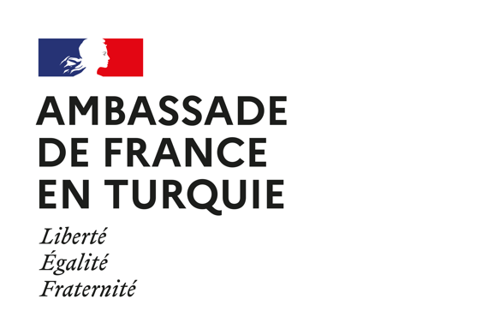
Regulations for the 2022 Environment call for proposals

ARTICLE 1: OBJECT

1.1. The French Embassy in Turkey, through its “Solidarity with developing countries” programme, supports civil society projects every year in accordance with its commitments for human rights and the sustainable development goals. In particular, this call is organised in order to support projects carried out by NGOs that contribute to the environmental protection in Turkey.
1.2. For our third call for proposals on Environment, we will pay attention to projects aiming to:
- Protect biodiversity;
- Mitigate and adapt to climate change;
- Environmental protection and fight against pollution.
1.3. They will raise public awareness on these questions; strengthen the technical capacities of civil society organizations; define strategies and / or disseminate good practices.

ARTICLE 2 – CONDITIONS

2.1. The application must be submitted in English and automatically involves the acceptance of these regulations.
2.2. The three to six projects selected will be granted between 5,000 and 12,000 euros each, for a total amount of 32,000€. The Embassy may decide to give a lower amount than what the applicant requested.

ARTICLE 3 - ELIGIBILITY CRITERIA

3.1. The projects must start between August 1, 2022 and be finalised before August 1, 2023.
3.2. They must integrate the traditional criteria of development aid, namely: relevance, coherence, effectiveness, efficiency, impact and sustainability. Visibility and the politico-social local context will also be taken into account.
3.3. Projects that will have a leverage effect to larger projects will be valued. The consideration of cross-cutting factors (gender equality, Human Rights, etc.) will also be valued. As far as possible, the project must involve other local partners. The project must take care to reduce CO2 emissions as much as possible. The projects will have to plan appropriate communication and transparency actions.
3.4. Only associations (Dernek) and foundations (Vakıf) are eligible for these founds.
3.5. The requested grant must not exceed 80% of the whole project budget and the operational costs (administrative costs (not directly related to the project), office equipment, and rent) must not outreach 25% of the whole project budget.

ARTICLE 4 – JURY

The jury will be chosen by the French Embassy in Turkey. It may include members of Turkish civil society, members of French local institutions and members of International Organizations.
ARTICLE 5 - APPLICATION PROCESS

5.1. The files of the candidate associations must be sent by email to the Cooperation with Civil Society Officer, at the address siviltoplum@ifturquie.org before June 5, 2022 at 11.59pm.
5.2. The documents to be provided are:
- Project proposal with budget
- Cover letter
- Statutes (Tüzük)
- The previous Final report (if you already have received funds from the French Embassy to Turkey).

ARTICLE 6 - PAYMENT OF ENDOWMENTS

6.1. A decision of the jury will be given by end of June/beginning of July 2022.
6.2. A grant agreement must be signed by the two parties (French Embassy in Turkey and winning organization) in order to release the grant.
6.3. The grant will be paid in euros or Turkish liras at the rate of chancellery in force on the date of payment.

ARTICLE 7 – MODIFICATIONS

7.1. Any significant change affecting the objectives, partners, calendar or budget of a selected project must be reported and validated by the French Embassy in Turkey.
7.2. Failure to comply with this clause or partial or complete non-completion of the project may result in the reallocation of the funding granted or the full or partial reimbursement of the sums.

ARTICLE 8 - OBLIGATION OF THE WINNERS

8.1. The winning association commits to return to the Embassy of France in Turkey a final report maximum two months after the end of its project. These documents will be signed and be submitted by e-mail within two months after the end of the project.
8.2. The winning association authorizes the publication and use by the Embassy of France and the French Institute of Turkey of its name, information relating to the funded project, intermediate and final reviews, photos, videos and waives collection any right or indemnity in this respect.
8.3. The winning association must use the logo of the French Embassy in any communication related to the selected project.
8.4. In the frame of the project, the winning association is strongly encouraged to solicit the French Embassy and the Institut français de Turquie (branches in Ankara, Istanbul and Izmir) for the organization of events (hosting facilities, invitation of French Embassy’s officers to discussion panels, etc.).

ARTICLE 9 - INSURANCE OF WINNERS

9.1. In the event of an accident, the winning association is solely responsible for their project and are covered by the necessary insurance. It therefore disclaims any and all liability from the French Embassy in Turkey and the funding bodies from any responsibility in the event of an accident and will not have any recourse against them.
9.2. The selected projects have to comply with the law and the funding body is not responsible for any illegal activity during the implementation of the project supported.

