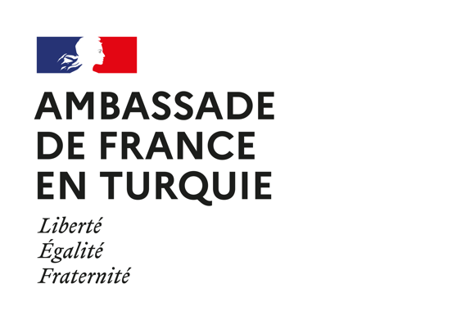

Regulations for the grant to the “Support for Biodiversity in Turkey” project

ARTICLE 1: OBJECT
The French Embassy in Turkey, through its programme “Solidarity with developing countries”, supports civil society projects every year in accordance with its commitments for human rights and the sustainable development goals. In particular, this call is organized in order to support projects carried out by small organizations which contribute to the protection of biodiversity in Turkey.
France is strongly involved at the national level and in multilateral fora to make the protection of biodiversity one of the priorities of major public policies and international cooperation. Biodiversity protection is one of the priorities of its diplomatic agenda and it is making numerous efforts, notably hosting the IUCN World Conservation Congress in 2021, to reach the adoption of a historic international agreement at COP 15 of the Convention on Biological Diversity (CBD) to be held in 2021.
The projects selected under this call will therefore aim to protect land, aquatic and marine ecosystems. They will make it possible to raise public awareness on these questions, to strengthen the technical capacities of civil society organizations, to define biodiversity protection strategies and / or to disseminate good environmental practices.

ARTICLE 2 - CONDITIONS
The project application for the Embassy of France in Turkey must be done in French or in English and automatically involves the acceptance of these regulations.

The amount of the grant is € 8,000. Two projects will be selected and will receive between 3,000 euros and 5,000 euros each. The subsidy must represent at least 25%, and at most 75% of the budget (valuations not included).

ARTICLE 3 - ELIGIBILITY CRITERIA
Concerning associations likely to submit a project:
- Associations must not have annual resources greater than €500,000 (cf. last approved annual accounts).
- Only associations (deneği) and foundations (vakıf) can submit a project.
- Only associations with more than a year of existence, set on the day of publication in the Official Journal, can submit a project.
- The projects must start before November 15, 2020 and be finalized before November 15, 2021. A financial and activity report must be made on this date.
- They can relate to all topics related to biodiversity
- They must integrate the traditional criteria of development aid, namely: Project sustainability, Innovation and replicability, Beneficiary involvement, Result indicators: ability to measure the short and long term impacts of the project.

Projects that will have a leverage effect to larger projects will be valued. The consideration of cross-cutting factors such as gender equality and persons with disabilities will also be valued. As far as possible, the project must involve other local partners.
The mobilization of volunteers or donations in kind must be valued in project budgets. The project must take care to reduce CO2 emissions as much as possible.
The projects will have to plan appropriate communication and transparency actions.

ARTICLE 4 - JURY
The jury will be chosen by the French Embassy in Turkey. It will include members of Turkish civil society, members of French organizations, and members of the French Institute in Turkey.

ARTICLE 5 - APPLICATION PROCESS
The files of the candidate associations must be sent by email to Mr. Alexis Lefèvre, at the address alexis.lefevre@ifturquie.org before Sunday August 23, 2020 at 11.59pm.

The documents to be provided are:
- Project proposal with budget
- Letter of application signed by the legal representative presenting the motivation for submitting the project and the amount requested.
- RIB with IBAN signed and dated.
- The latest accounts of the association.

ARTICLE 6 - PAYMENT OF ENDOWMENTS
A first decision of the jury will be given in the first week of September 2020.
A grant agreement must be signed by the two parties (French Embassy in Turkey and winning organization) in order to release the grant.
The grant will be paid in euros or Turkish liras at the rate of chancellery in force on the date of payment.

ARTICLE 7 - MODIFICATIONS
Any significant change affecting the objectives, partners, calendar or budget of a winning project must be reported and validated by the French Embassy in Turkey. Failure to comply with this clause or partial or complete non-completion of the project may result in the reallocation of the funding granted or the full or partial reimbursement of the sums

ARTICLE 8 - OBLIGATION OF THE WINNERS
The winning association commits, at the end of its project, to return to the Embassy of France in Turkey a signed narrative and financial report. These documents will be signed and be submitted by e-mail within two months after the end of the project.

The winning association authorizes the publication and use by the Embassy of France and the French Institute of Turkey of its name, information relating to the funded project, intermediate and final reviews, photos, videos and waives collection any right or indemnity in this respect. The winning association must display the logo of the French Institute in Turkey and the Embassy of France on communication media related to the project. The winning association must also facilitate any evaluation of the project.

ARTICLE 9 - INSURANCE OF WINNERS
In the event of an accident the winning association, is solely responsible for their project and are covered by the necessary insurance. It therefore disclaims any and all liability from the French Embassy in Turkey and the funding bodies from any responsibility in the event of an accident and will not have any recourse against them.

